There are 4 questions found in black boxes within the text. Answer these questions in a Google Doc or Word Doc and submit for grading.
You may want to listen to the chilling audio of "A Ghost" while you follow along with the text.

This is the video
https://youtu.be/v_3hkBMXx2M
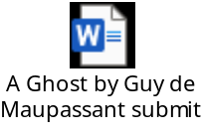
Right click and open the file

